CHAPTER 9: Sedimentary, igneous and metamorphic rocks
Worksheet 9.2

Igneous rocks
Answers

1. (a) The figure below left shows a region of past igneous activity. Igneous rocks are found in the two locations marked by arrows. Label these rocks as either intrusive igneous rocks or extrusive igneous rocks.
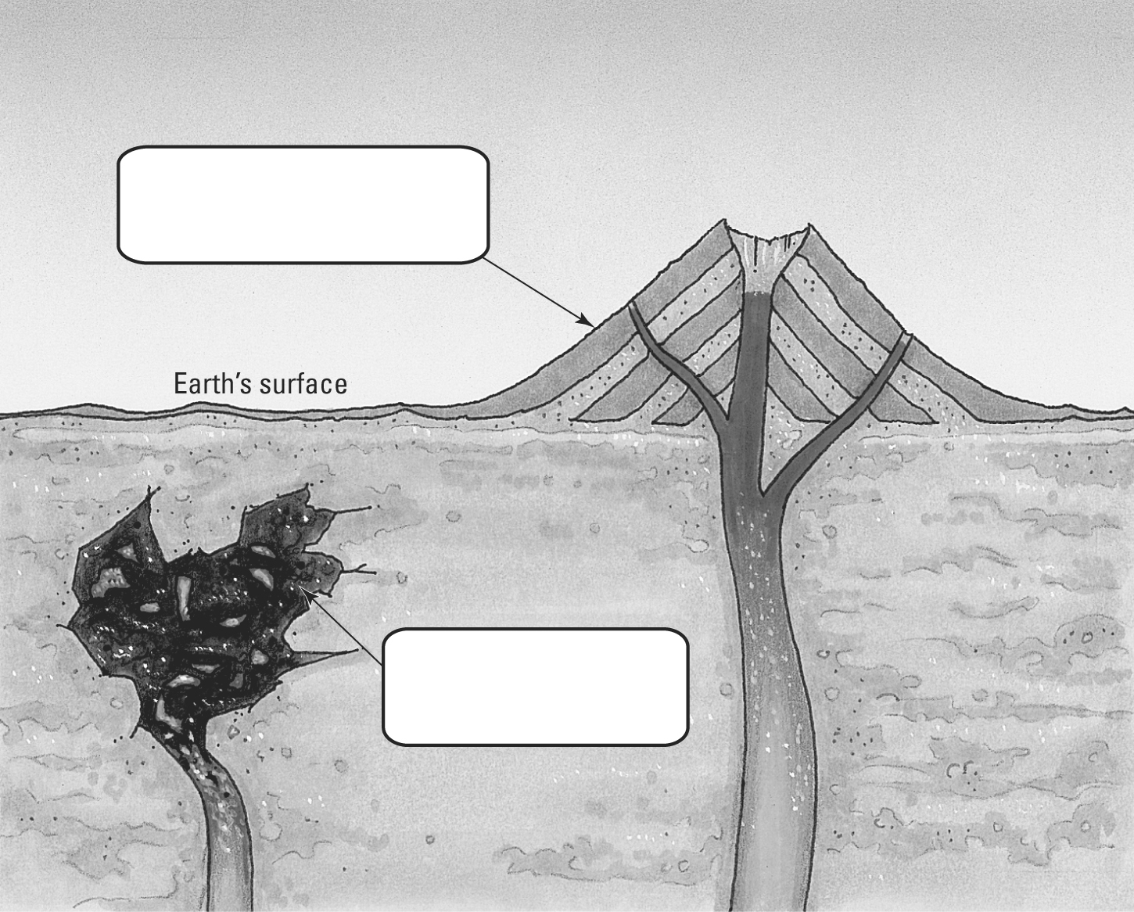 | (b) The photos below show sections of rocks taken from these sites. Section A is coarse grained, and section B is fine grained. Identify which rock is intrusive and which extrusive.
 | 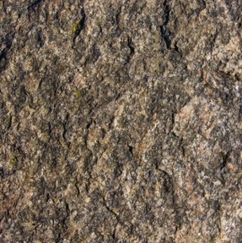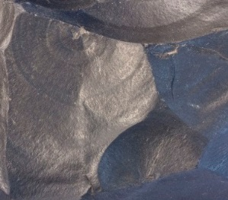
 | Section A Section B
Extrusive
Intrusive
2. Read the information about various igneous rocks and create a written classification key to distinguish them.
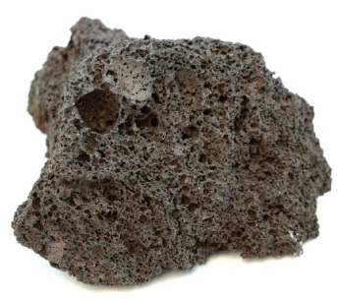 | 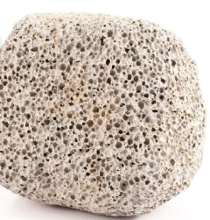 | 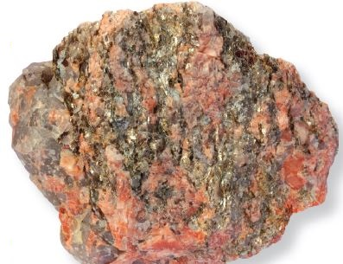
Scoria | Pumice | Granite
Pumice: pale coloured rock; very light; very porous; many small gas holes
Scoria: red-brown or grey rock; light but heavier than pumice; porous; small and large holes
Obsidian: smooth, glassy black rock; non-crystalline
Granite: hard; dense; large crystals; speckled colours (white, black, glassy, pink)
Basalt: grey or black rock; very fine crystals; hard; dense

Section A photo: Victor Azovkin / 123RF.com
Section B photo: Siim Sepp / 123RF.com
Scoria photo: Tyler Boyes / Shutterstock.com
Pumice photo: Rob Kemp / Shutterstock.com
Granite photo: Siim Sepp / Shutterstock.com

Key:
1A. Rock is porous go to 2
1B. Rock is not porous go to 3
2A. Rock is pale in colour and very light .pumice
2B. Rock is red or grey .scoria
3A. Rock is smooth, black and glassy obsidian
3B. Rock is not smooth, black and glassy go to 4
4A. Rock is speckled with large crystals .granite
4B. Rock is grey or black with fine, dense crystals basalt

